1.

Which of the following is arranged in ascending order?
A.
-25, -64, 4, 17
B.
-64, -25, 4, 17
C.
-64, -25, 17, 4
D.
17, 4, -25, -64

2.

If P = {x:x is an even number greater than two and less or equal to twelve}, list the members of P
A.
{2, 4, 2, 8, 10, 12}
B.
{3,4,6,8,10,12}
C.
{2, 4, 6, 8, 10}
D.
{4, 6, 8, 10, 12}

3.

Which of the following is an infinite set?
A.
{1, 2, ..., 5, 6, 7}
B.
{4, 6, 8, 10, 12}
C.
{2, 3, 5, 7, 11, ...}
D.
{3, 6, ..., 18, 21, ...33, 36}

4.

Find the H.C.F. of 18, 36 and 60.
A.
2² x 3² x 5
B.
2² x 3²
C.
2 x 3 x 5
D.
2 x 3

5.

Write two hundred and two million, two thousand, two hundred and two in figures.
A.
202,002,202
B.
202,020,202
C.
202,022,202
D.
202,200,202

6.

Find the least number that can be added to 207 to make the sum divisible by 17.
A.
3
B.
13
C.
14
D.
30

7.

If P = {factors of 36} and Q = {multiples of 4 less than 40}, find the number of subsets in P∩Q
A.
10
B.
8
C.
6
D.
4

8.

Find the L.C.M of 10, 15 and 25.
A.
90
B.
120
C.
150
D.
300

9.

Evaluate

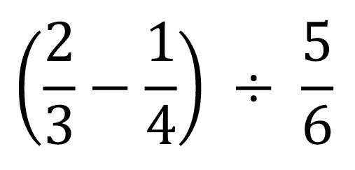
A.
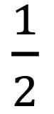
B.
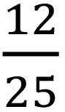
C.
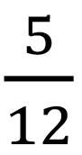
D.


10.

Arrange

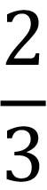

,

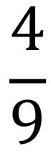

and

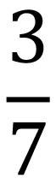

in ascending order.
A.

,

,

B.

,

,

C.

,

,

D.

,

,

11.

Find the simple interest on GH₵ 600.00 saved for 2 years 8 months at 5% per anum.
A.
GH₵ 64.00
B.
GH₵ 80.00
C.
GH₵ 84.00
D.
GH₵ 92.00

12.

The number of girls in a mixed school is 420. If the ratio of boys to girls in the school is 3:2, how many students are in the school?
A.
1050
B.
1470
C.
1630
D.
1680

13.

Mary had a chance to select a number from 1 to 20 randomly. What is the probability that the number is divisible by 3?
A.
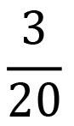
B.
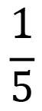
C.
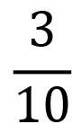
D.
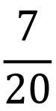

14.

Ama bought a pair of sandals for GH₵ 20.00 and solid it at GH₵ 24.00. Find the percentage profit.
A.
4 %
B.
17 %
C.
20 %
D.
44 %

15.

8 men can do a piece of work in 12 days. How long will 6 men take to do the same work if they work at the same rate?
A.
14 days
B.
16 days
C.
18 days
D.
20 days

16.

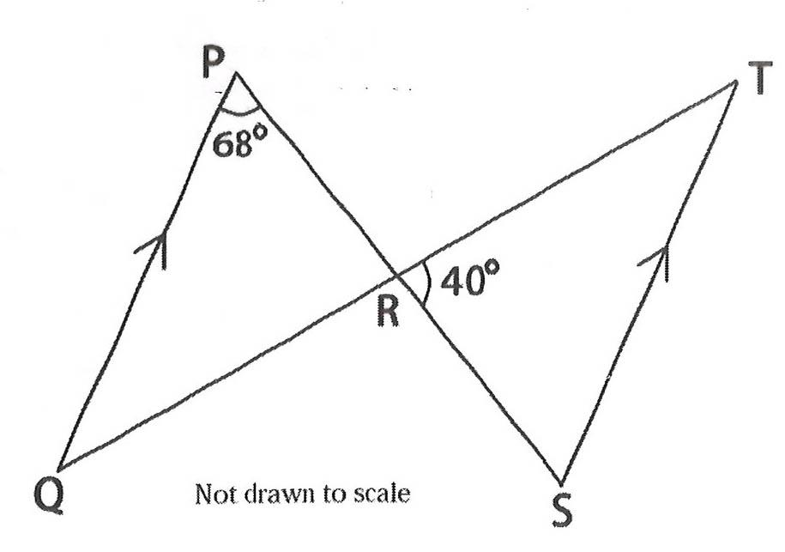
In the diagram, QP is parallel to ST, angle QPR = 68º and angle SRT = 40º.
Use the information to answer the question below:
Find the value of angle PQR.
A.
40º
B.
68º
C.
72º
D.
108º

17.

In the diagram, QP is parallel to ST, angle QPR = 68º and angle SRT = 40º.
Use the information to answer the question below:
Find the value of angle TSR.
A.
40º
B.
68º
C.
72º
D.
112º

18.

A train is travelling at a speed of 60 km/h. What distance will it cover from 10.45 am to 12.15 pm?
A.
75 km
B.
87 km
C.
90 km
D.
150 km

19.

The perimeter of a rectangle is 26 cm. If its length is 10 cm, find its area.
A.
30 cm²
B.
60 cm²
C.
130 cm²
D.
160 cm²

20.

Find the slope of the line 3x - 6y = 33.
A.
-3
B.
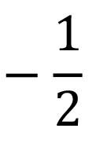
C.
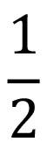
D.
3

21.

If y = c + bx², find y when c =
14
5
, b =
4
5
and x = 2.
A.
3
B.
4
C.
6
D.
7

22.

The volume of a cylinder is 20 π cm³. If the height of the cylinder is 5 cm, find the base radius.
A.
1 cm
B.
2 cm
C.
3 cm
D.
4 cm

23.

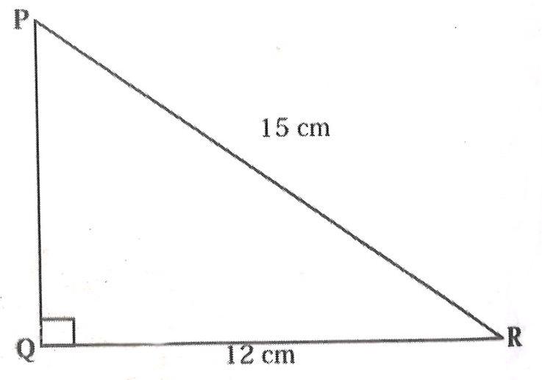
Not drawn to scale
In the diagram, PQR is a right-angled triangle with |PR| = 15 cm and |QR| = 12 cm. Find the length PQ.
A.
3.0 cm
B.
8.0 cm
C.
9.0 cm
D.
19.2 cm

24.

How many edges has a triangular prism?
A.
3
B.
5
C.
6
D.
9

25.

Make m the subject of the relation:
q =
1
3
(m + n)h
A.
m =
3q
h
- n
B.
m = 3q - hn
C.
m = 3q + hn
D.
m =
3q
h
+ n

26.

Simplify 16² x 8²
A.
2¹⁰
B.
2¹⁴
C.
2¹⁵
D.
2¹⁶

27.

simplify: 4a - 9b -2(2a - 3b).
A.
8a + 3b
B.
8a - 3b
C.
-15b
D.
-3b

28.

If u =
(
3
1
)
and v =
(
-2
1
)
, evaluate 6v + 2u.
A.
(
-1
3
)
B.
(
-6
8
)
C.
(
1
3
)
D.
(
6
8
)

29.

Find the image of the point (2,5) under the transformation
(
x
y
)
→
(
x
2 - y
)
.
A.
(2,-3)
B.
(2,2)
C.
(2,3)
D.
(2,7)

30.

Find the image of Q(-4,5) when rotated anticlockwise through 90º about the origin.
A.
Q¹(-5,4)
B.
Q¹(-5,-4)
C.
Q¹(4,-5)
D.
Q¹(4,5)

31.

The following data show the marks of students in a test:
10,4,1,4,3,3,2,1,1,7,8.
Use the information to answer the question below.
If the pass mark is 4, find the number of students who scored more than the pass mark.
A.
1
B.
2
C.
3
D.
4

32.

The following data show the marks of students in a test:
10,4,1,4,3,3,2,1,1,7,8.
Use the information to answer the question below.
Find the mean mark
A.
3
B.
4
C.
7
D.
8

33.

How many lines of symmetry has a rhombus?
A.
2
B.
3
C.
4
D.
5

34.

In an enlargement length AB = 3 cm and the length of its image A₁B₁ = 15 cm. Calculate the scale factor.
A.
1
5
B.
2
3
C.
5
D.
12

35.

Find the rule of the mapping:
x | 0 | 3 | 6 | 9 | 12
↓ | ↓ | ↓ | ↓ | ↓ | ↓
y | -2 | 4 | 10 | 16 | 22
A.
y →
x
2
- 2
B.
y → x - 2
C.
y → x² - 2
D.
y → 2x - 2

36.

Solve the inequality:
1
2
(3x - 1) + 1 ≤ 7 + 2x.
A.
x ≥ -14
B.
x ≤ -14
C.
x ≥ -13
D.
x ≤ -13

37.

If 4 - x = 3(4x + 5), find the value of x.
A.
11
13
B.
1
6
13
C.
-1
6
13
D.
-11
13

38.

In a class, there are 12 girls and 48 boys. Find the percentage of boys in the class.
A.
20%
B.
40%
C.
60%
D.
80%

39.

The bearing of P from Q is 060º. Find the bearing of Q from P
A.
120º
B.
150º
C.
210º
D.
240º

40.

Which of the following statements best describes the construction below?
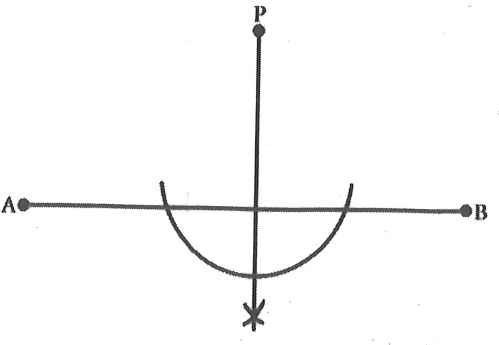
A.
Construction of line AB from P.
B.
Construction of perpendicular from P to meet line AB.
C.
Construction of an arc of a circle with center P.
D.
Construction of the bisector of line AB.

